# User Manual

## Getting Started

On any preferred browser, navigate to the URL <http://apollo.matthewteolis.com/>

The homepage will appear as displayed on Figure 1. From there the user may choose to navigate to the following options:

1. **User Setting**

The user can click on his avatar or name to display their profile information or change his/her password and preferences.

1. **Toggle Sidebar**

The toggle sidebar is used to hide/show the sidebar. By default, the sidebar is displayed on large devices such as computer screens or tablets, and it is hidden on smaller devices such as smartphones.

1. **Sidebar**

The sidebar is used to navigate to various other sections of the application.

1. **Application Home Button**

At all times, the user can click on the Apollo home button on the toolbar at the top of the page to navigate back to the homepage

1. **How-To Video**

There is an embedded Youtube video on the homepage providing a detailed walkthrough of the application.

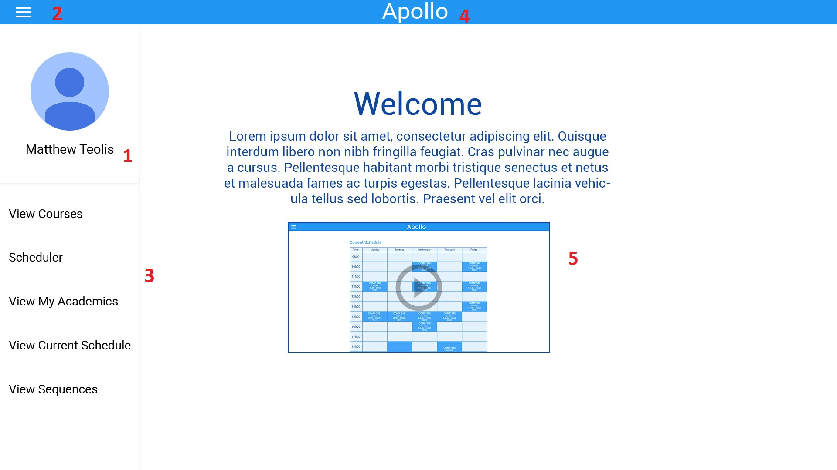

## Selecting Courses

After navigating to “View Courses” page from the sidebar, the user will be able to select the courses he/she wishes to enroll in.

The user will have the following options:

1. **Search Courses**

The search bar is used to search for classes offered by concordia. The classes are filtered dynamically so the classes that match the search query appear as the user types.

1. **Generate**

The Generate button, once pressed, will display the generated schedules using the selected classes to the student. (See “Generated Schedules” below)

1. **Selected Course Chip**

When the student selects a course, a chip matching the course will appear under the search bar. These chips represent the set of courses the user wishes to generate the schedule with. Courses can be easily removed from the set by clicking on the X in course’s chip.

1. **Course List**

The course list contains the courses offered by Concordia. The list changes dynamically to match the search query as the student types inside the search bar.

1. **Course Details**

Details about the selected course is displayed when the user clicks on the course’s box. This includes the course description, requisites, credits and faculty.

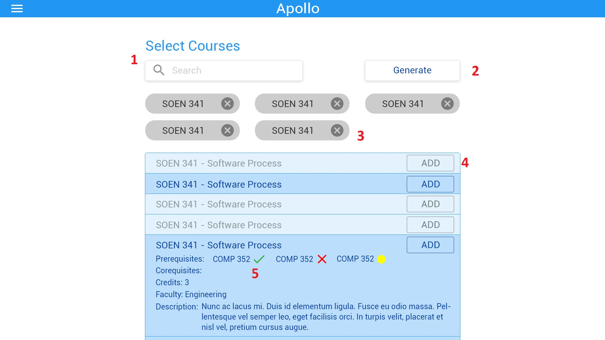

## Generated Schedules

Once the user clicks on the “Generate” button, the page containing containing all the schedules created by the scheduler will be displayed.

The following elements are shown:

1. **Return to Courses**
   1. If the user wishes to make changes to the selected courses, the “Return to Courses” button will return the user to the previous screen.
2. **Schedule Preferences**
   1. The user can indicate their scheduling preferences. By default, “All Day” is selected, indicating that courses can be scheduled any time of day. The user can change their preferences and the scheduler will only include the schedules that match the preferences specified.
3. **Schedule**
   1. Every possible schedule combinations will be displayed as a table.
4. **Save Schedule**
   1. This button saves a selected schedule into the user’s “Saved Schedules” page. The user can refer to the schedule at any time after saving it.

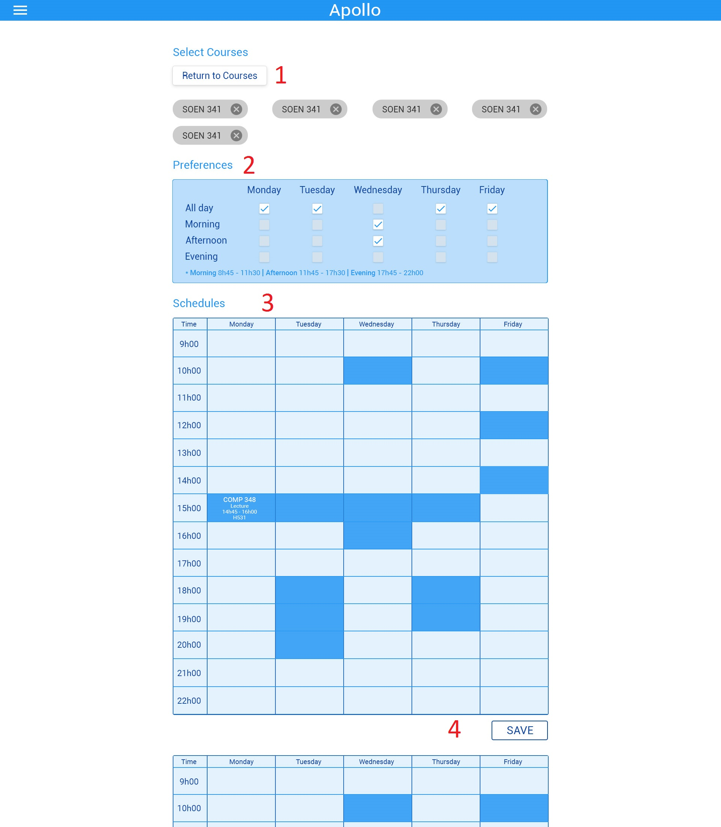

## Edit Preferences

Once the user navigates to their profile page, they can change their password or preferences.

The following elements are displayed:

1. **User Profile Information**

Details about the user’s academic information are displayed here.

1. **Change Password**

The user can change their password.

1. **Edit Preferences**

The user can change their scheduling preferences (ex. Morning, Afternoon, Night).

